<< Home >> Lo primero que ve el cliente al ingresar a la web
THINK TRANSFORMATION
Disruption is a force that is changing corporate landscape
Technology impacts directly in business models and the way customers interact
What is the biggest digital challenge you face at your business?
Digital Transformation Starts at the Top
------------------------------------------------------------------------------------------------------------------------------
<< Segundo Scroll en Home >>
What We Do?
Ombu´s professional services include Technological consulting services which help to digitize and update businesses to the new tech era
Create value by increasing productivity, saving costs and adding new sources of revenues with digitalization
Provide IT resources & services for SME´s that lack off IT specialists in house
------------------------------------------------------------------------------------------------------------------------------
<<Tercer Scroll en Home>>
Resilient Businesses: Lead Innovation
Advisory Services Software Solutions
Artificial Inteligence Machine Learning Data Modernization
Cloud Services Biometric Solutions App Development
Tailored made digital Development and software solutions implemented over client´s platforms
Provide clients with access to state-of-the-art technologies created in house and by our internationally recognized partners
------------------------------------------------------------------------------------------------------------------------------
<<Cuarto Scroll en Home>>
Our Value Proposition
SOLID BUSINNESS Management with 20+ years of experience in the tech industry

TRACK RECORD Our global and regional experience helps us to better understand client’s needs

IT UNPARALLELED IT and software development team with 25 + years in the industry EXPERIENCE

TOP TIER GLOBAL PARTNERS Provide us access to the latest and most innovative technologies worldwide. Working with top companies gives enhances our skills and gives us more depth and speed in a fast-moving industry

REASONABLE PRICING Our teams based in Argentina combined with our result-oriented transformation help our clients to reduce costs and increase sales at low cost

------------------------------------------------------------------------------------------------------------------------------------------
Quinto Scroll en Home
<<About Us >>

We have known in the last 10 years in the financial industry in Latin America
The Tech Industry have developed worldwide, and our professional careers and knowledge have been
demanded in many aspects around the world. As a result of this growing need, we decided to bring to
the region a company that provides consulting & implementation to the needs of our clients providing
efficiency and maximizing businesses from a digital vision

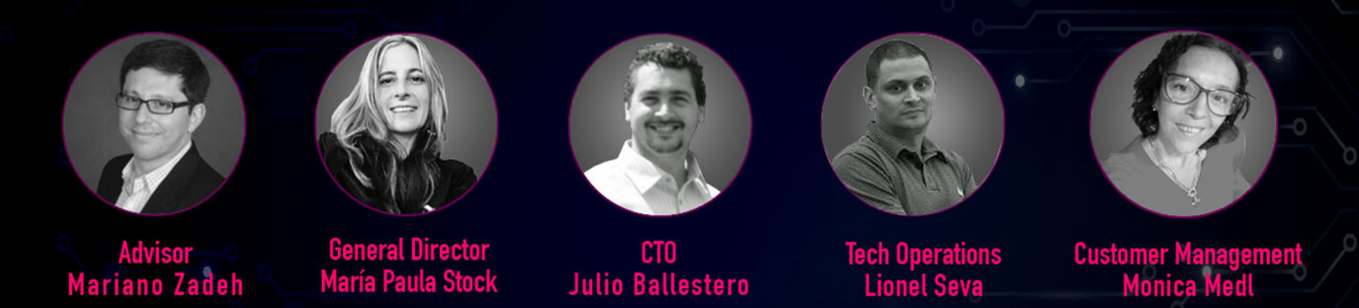

Poner la URL a cada uno a sus LinkedIn

<<Sexto Scroll en Home>>
Contact Us

Formulario con campos para completar de la empresa que desea contactarnos

Company Name:
Industry:
Country:
Name of Contact:
Title:
Contact Number:
Email Contact:

A uno de los costados del formulario de contacto debe estar la información de la empresa
OMBU en Argentina como en EEUU

Buenos Aires Miami
1350 Basavilbaso Street 200 S Biscayne Blvd
5th floor 27th floor
City of Buenos Aires Miami, Florida
Argentina USA

Mail de contacto: info@ombutech.net (esto debe ir de alguna manera que quede claro que es
para cualquiera de las 2 ciudades)

También se debe agregar las redes sociales de Ombutech: Linkedin / Facebook / Instagram
------------------------------------------------------------------------------------------------------------------------------

- PRODUCTS

Loan Management Software

Automates your entire Lending Process
End-to-end securities-based platform
Connects lenders seeking high-quality loans with borrowers requiring convenient access to credit

Key Features

White Label Platform Speed Technology Loan Product Suite

Smart Acquisition State-of-the-art Underwriting Customer reach through
Omnichannel tool
Lending Analytics Collection Workflow Balancing & Overdue

Interest & Charges Application Identity Validation Modular API-Based
methodology and highly customizable product

Estas deben ser secciones dentro de este apartado
- End-to-end lending hub

Scalable, fast, flexible and agile while becoming cost efficiency
Improve productivity and customer service through the entire loan lifecycle

- AI Credit Scoring

Better Credit Decisions
Offers Configurable Product rule engine
State-of-the-art underwriting algorithm
Credit Scorecards based on alternative data
For banked & unbanked customers

- Biometric Solutions +
Machine Learning for client Recognition

Fast fingerprint & face recognition technology
Machine learning algorithms for mobile & web to detect fraud

- Payment Solutions

Easily & Quickly accept and receive payments
Different Payment Solutions offered to borrowers
API-based integration system customizable for lenders

- Business Outcomes (BI)

Cost Reduction
Innovation
Risk Reduction
Revenue Generation
Speed-to-Market

- SERVICES

Digital Transformation Consulting

Capitalize on New-Age Digital Ecosystems to enable product innovation, enhance customer experience and boost operational efficiency

Growing emphasis on continuous innovation driving the demand for state-of-the-art digital capabilities. However, a lack of understanding domain and its measurable impact pose a challenge in leveraging digital technology across the business value chain

- CTO Services

We provide CTO services for startups that lacks IT teams from their beginning

Also provide these services for our clients that initiate a digital transformation and want to navigate throughout this process with a seasoned team like ours

- Data Modernization

Data Driven Management
Use of data to improve the efficiency of operations and drive innovation
Build a Data Driven Culture through the company
Drives smarter business decisions

With I Data Modernization, expect a data platform for on-the-fly reporting and dashboards, remote access, unification and visualization

Big data and modernization strategy, including a roadmap that aligns with your business objectives and legacy system integration

Data lakes to capture a wide range of data types, analysing raw data and processes for discover. Allows you to leave all your data stored across multiple systems, and access it one place

- Cloud Services & Integration Support

Transition to Hybrid Cloud Infrastructure for Business Growth and Agility
Help companies enhance operational agility by migrating enterprise applications from on-premise to cloud. Worked with leading cloud platforms such as AWS, Azure and Google Cloud
Scalability to meet increased business needs
Business continuity through available infrastructure

- Biometric Solutions

Identifying our customers
Easily Securely biometric technology

Solution that is easily deployed, secure and scalable for applications installation
Services can be performed even in the most remote area with lack of infrastructure
Peace of mind transactions conducted in a secure environment
Multi-factor authentication

- App Developments

Research
Wireframing – Technical Feasibility Assessment
Prototype – Design
Develop – Testing
Deployment
Support & Maintenance

